
Dashboard Design

Date | 21 September 2026
Team ID | MCA(Master of Computer Applications)
Project Name | Air Quality Intelligence: India Air Pollution Monitoring, Operational and Risk Analysis
Maximum Marks | 5 Marks

Creating an effective dashboard involves thoughtful design to ensure that the presented information is clear, relevant, and easily understandable for the intended audience. Here are some key principles and best practices for dashboard design
Activity 1: Interactive and visually appealing dashboards
Creating interactive and visually appealing dashboards involves a combination of thoughtful design, effective use of visual elements, and the incorporation of interactive features. Here are some tips to help you design dashboards that are both visually appealing and engaging for users so take care of below points
- Clear and Intuitive Layout
- Use Appropriate Visualizations
- Colour and Theming
- Interactive Filters and Slicers
- Drill-Down Capabilities
- Responsive Design
- Custom Visuals and Icons
- Use of Infographics

Dashboard Outcomes (Air Quality Intelligence)
Here are five potential outcomes from my Air Quality Intelligence dashboard:
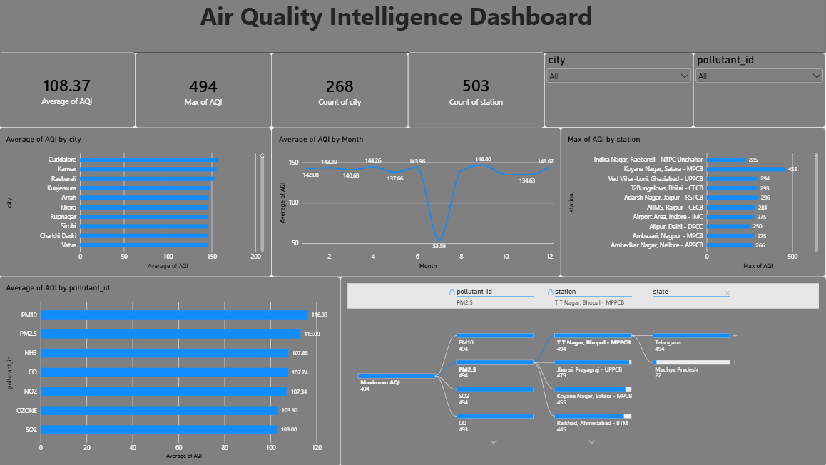

1. Overall Air Quality Status: The dashboard shows an average AQI of 108.37 across all monitored readings, which falls in the "Unhealthy for Sensitive Groups" range, and a maximum recorded AQI of 494, close to the "Hazardous" ceiling.
2. Monitoring Coverage: The dashboard tracks 268 cities and 503 monitoring stations, confirming broad, high-resolution national coverage rather than a handful of concentrated hotspots.
3. City-Level Hotspots: Cuddalore, Karwar, and Raebareli top the Average AQI by city chart, showing that mid-sized/industrial cities — not just major metros — register the most severe average pollution.
4. Seasonal/Monthly Anomaly: The Average AQI by Month line shows a sharp, isolated dip around month 6 (53.59) against an otherwise consistent 134–147 range, suggesting a data gap or a genuine short-term environmental event worth validating.
5. Pollutant and Drill-Down Insight: PM10 (116.33) and PM2.5 (113.09) are the highest-averaging pollutants, and the Decomposition Tree drills from the overall Maximum AQI (494) down through pollutant, station, state, and city — pinpointing exactly which locations drive the worst readings.

